Papier Mosaic Insight

Explanation:
There are many ways to create art. We are excited to focus on a diverse media and technique in our ‘Papier Mosaic’ style paintings. We incorporate all sorts of paper and love the way each little bit has a unique color nuance… it is like painting with paint that has ‘personality’. Each element of paper has a character which helps us build unique paintings.

Advantages:
We are able to work on this art with the comfort that it is earth-friendly and non-toxic. We are also surrounded with endless materials to use for our paintings. Working on this art also has another element of ease… we are able to step away without the worry of drying paint, product that is wasted and accidentally getting paint on our clothes or furnishings.

Paper Sources:
Art Books Maps
Calendars Old Books
Colored Paper Painted Paper
Construction Paper Scrapbooking Paper
Crafting Paper Sheet Music
Greeting Cards Wall Paper
Magazines Wrapping Paper

Note: Use the highest quality paper available to you. A] When sourcing magazines, be sure to use those that have the nicest sheen and thickness. This will allow you to create a lovely picture with less showing through from the underside of the paper. B] Using the best paper will also minimize fading. Place your artwork away from direct sun for assurance that it will last for many years. You may also want to frame your painting with glass that offers UVA protection. Additionally, there are sprays available that also offer UVA protection and non-yellowing features.

Tools:
Board that resists bending or curving… such as Gator Board or Canvas
Scissors – Regular, Straight Edge
Scissors – Decorative Edge in Variety of Styles [Optional]
Clear School Glue
Brush – Flat Edge
Tweezers – Quilling Style [Optional]
Paper [Such as those listed above to use for ‘painting’ your art]
White Board – Used to sort your paper color pieces after they are cut
Pencil – White Lead to draw your subject onto the dark surface

Helpful Notes:

1] I find it most helpful to paste on a BLACK [or darker] surface. This helps to ‘hide’ any type or images that may be on the back of the paper you are using in your art. [We do experiment with lighter values of the surface we are pasting on… this is very much working to find out what is best with your paper source.]
2] Lightly draw your subject onto the black surface with a white colored pencil. Remember you will have to paste over any white lines that you draw because you don’t want them to show on your finish painting. [Review ‘How to Transfer Images’ outlined below.]
3] Cut up your paper first and create a palette of colors. Cut more than you anticipate using due to the fact that you will paste and overlap the edges of what you paste on your artwork. Try not to use pieces that are too large as they tend to ‘ripple’ after you paste them. I like to keep my paper the size of a quarter or smaller depending on the desired result of my design. [The smaller the piece the more control you will have over edges and the ‘gradient’ look of your work.] Place these little pieces on your white paper or board so you can see them easily and sort the colors as you work. Apply the clear glue onto your board, only where you want to apply the paper, use the tip of your brush to pick up the one piece of paper and apply to the board. Voila! Just like paint!
4] You may cut or tear your paper. If you would like a soft look then tear your paper, remember that if you pull the paper toward you with your right hand, then that side will have more of the color showing and not the back side of the paper. If you prefer a clean edge then cut with scissors. You can mix these methods in your painting for a variety of edges. There is no right or wrong way to paint with your paper.
5] Work from the background to the foreground. This is important because you want the elements that are closest to you to lay on top of what is behind them. [This is an easy thing to forget… I do it all the time. No worries… you can always layer over anything you paste. This is a very ‘forgiving’ type of art process.]
6] Remember to have your art ‘flow’ with the Shape of the object. When you are cutting your paper, sometimes they will be square or triangle; if you tear them they will be all sorts of different shapes. When you are creating the ‘shape’ on your painting, use the little piece of colored paper that will best help create the shape. For example, if you have a shape that is like a crescent moon, use it on the side of the piece of fruit that will help convey the curve of the fruit.
7] When complete, cover your entire artwork with a thin coat of glue for an even sheen and protection. Remember that different types of paper absorb the glue differently. This adds to a unique finish and look to your little individual pieces of paper. Let your board dry on a flat surface, do not dry in a vertical position or your glue will run.
8] If desired, you may also coat your artwork with Glitter. In a small jar mix together glue and glitter. Depending on humidity, measurements may vary. Try to begin with a cup of clear school glue, then add one tablespoon of glitter. If this is too thick, add a few drops of water and mix well. You may add additional glitter if you prefer a more glistening finish. Brush this special combination over your entire art… or just those areas you wish to highlight. [We use Non-Toxic, Extra Fine, Crystal Diamond Glitter.]
9] You may clean your brush with warm water and a little soap. This is important, if you invest in a nicer brush for your painting - you will want to keep them in perfect condition.

Subjects to Consider:
- Flowers [Individual Stems or a Vase of Flowers]
- Cats & Dogs, Frogs, Butterflies, Bees,
- Fruit [Apples, Pears, Cherries, Grapes, Watermelon, Strawberries, etc.]
- Words [Love, Friendship, Compassion, First Names, Initials, etc.]
- Hearts, clover,
- Coffee Cup & Saucer,
- Birds
- Cupcakes, Candy,
- Bikes, Toys, Fire Trucks, Dolls,
- Eiffel Tower,
- Lighthouse, Boats,
- Landscapes, Sunsets, Forest Views,
- Purse, Shoes, Jewelry,
- NOTE: Never copy artwork. Take inspiration and color cues from art, drawings, paintings and collage work… use this, along with your photographs or designs to make your artwork personal. You have permission to use any of my original art that I use in our workshops to create you art or provide a starting point for your unique paintings.

HOW to transfer Images:
There are many ways to transfer your designs. I have listed ideas that may be helpful to you.

- Grid Method – Take a copy of your art or photograph and draw a grid over top. Then draw the same type of grid onto your blank board or canvas. This will help you transfer sections from your copy to the surface of your artwork.

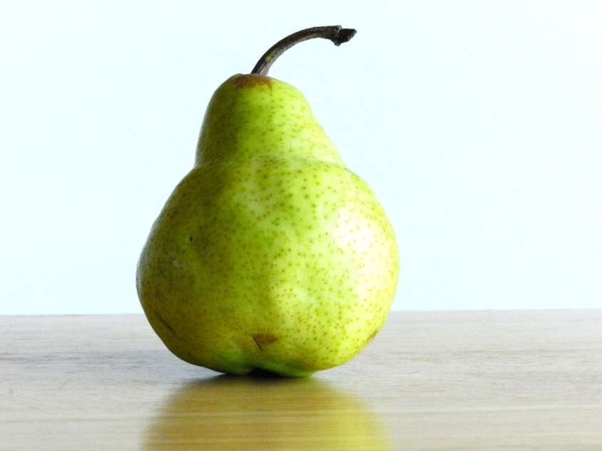

- Tracing Paper and Carbon Paper Method - Using a lightbox [or a window on a sunny day], place a piece of tracing paper over your artwork and trace the design. You may then cut out the tracing paper to make a template. Simply trace the design onto your blank board or canvas and then begin painting. You may also transfer your design by tracing the design onto the tracing paper, then on the back side, scribble with chalk over the surface. Place the tracing paper onto your blank black board and use a ball point pen to draw over the lines you have drawn. This will transfer the chalk from the tracing paper onto the black board. It is a little messy, but will get your design onto the surface. Use a white pencil to more accurately draw your image and then you will be able to begin painting your little elements of paper onto the surface.

To Frame:
Our most popular way to frame is to find a ‘shadowbox’ style frame in which to place your art. In addition to black there are additional colors of white and wood tones that will highlight and complement your art. [You will be able to find shadowbox styles at Pat Catan’s, Michael’s, Hobby Lobby and other art and craft related retail stores.]

Why Create Art?
Art is a Natural Human Behavior / Art is Communication / Art is Healing / Art Tells a Story
Art is a Shared Experience / Art has the ability to add Beauty to our World / Art is Self-Expression
Art is Creativity / Art is an Intellectual Puzzle / Art is Freedom / Art has no Wrong Answers
Art is a Fulfilling thing to do as a Conscious & Creative Individual
Art Challenges Us / Art allows us to Give & Share with Other

